Description

StreamSmith runs as a standalone RTSP server on a MediaCluster server as a reliable NT service to accept RTSP requests or TianShan invocations. It drives the stream execution over SeaChange Vstream. It is also a dynamic server-side playlist executor and supports back-to-back items and critical-start items in the list.
StreamSmith offers users a flexible extension opportunity with modules, a plugin-architecture. User will be able to customize the process for RTSP requests with applying various business application logic, or define own RTSP specification extensions.

Features

The SeaChange StreamSmith consists of the following features:
- Standalone RTSP server-side – a socket server with RTSP protocol support:
RTSP, RFC 2326
SeaChange Interactive Television Real Time Streaming Protocol Client Interface Specification, 2.0.3
up to 2000 concurrent connections
session context management
Following verbs are supported:
OPTION, DESCRIBE, SETUP, PLAY, PAUSE, TEARDOWN, PING
Support of SSL on RTSP connection
- Dynamic server-side playlist support – sequent stream automation
Flexible on-fly list operations: insert, erase, seek…
Support of back-to-back items and critical-start items
- Plugin framework – provide flexible customization opportunities
Business application logic map to plugin
Private business context
External application service support
- Local Vstream resource management –
manages local streaming resource at VstreamPort level
- Standalone Streaming w/o SeaChange Axiom –
StreamSmith will be able to stream off a MediaCluster node directly without Axiom’s help. The content can be ordered as simple as the filename in SeaFile file system
- Support of Motorola ECM pre-encryption MPEG files

The ssm_TianShan Module

The ssm_TianShan is the default plugin shipped with StreamSmith. It exports definitions of TianShan StreamService interface and its derived interfaces as remote API:
- Exports StreamService interface – allow remote client to create stream instance, query streamer devices and net id
- Exports Stream control interface – allow remote client to play, change speed, seek, stop a stream instance
- Exports Playlist control interface – allow remote client to insert, remove the items of a playlist. Query the current playing location, list size and so on
Accept the attachment of ConditionalStreamControl – to authorize with the remote module about an on-going stream control operation

Compatibility

- SeaChange Vstream 5.3.2a, 5.3.11, 5.4RC1 are supported in StreamSmith 1.6 (please verify the file version)
- Pure IP streaming is supported since StreamSmith 0.1
- DVBC network is supported since StreamSmith 1.3
- VLC player (www.videolan.org/) is supported in StreamSmith 1.6 w/ ssm_basic module
- RTSP spec of Sledgehammer (Axiom 4.0-) is supported in StreamSmith 1.5 w/ ssm_tianshan_s1 module
- TianShan API is supported since StreamSmith 1.5 w/ ssm_TianShan module.
- Compatible with SSL 1.0 and 2.0

Limitations

StreamSmith doesn’t and will not support schedule batch submit; a playlist must be built with exported atomic list operations.

Content management will not be covered within StreamSmith, it requires additional ContentStore implementation

Performance Characteristics

- StreamSmith can handle up to 2000 concurrent connections. At this level, StreamSmith will use around 200MBytes of memory and 30% of one Xeon 2.4Ghz processor
- With the ssm_basic module, StreamSmith can setup one stream in 200-500 milliseconds, and control an on-fly stream in 100-300 milliseconds

Not Available in This Release

- Load balancing on server instances and network is not covered in standalone StreamSmith. When load balancing is a must, it is required to setup StreamSmith in a TianShan deployment

Configuration

In a typical single node SeaChange MediaCluster, the following diagrams show StreamSmith service and its installation directory layout structure.
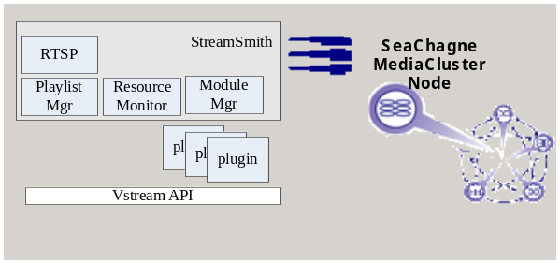

Service Lifecycle Diagram

StreamSmith work as an NT service, its lifecycle covers initialization, service loop and uninitlization as shown
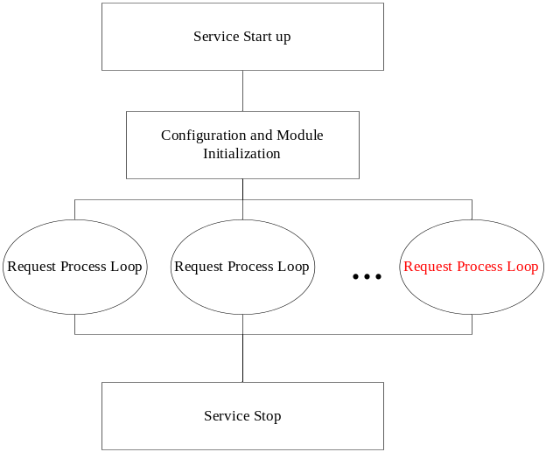

RTSP Request Process Loop

Every request come into the server will be processed by following the below loop:
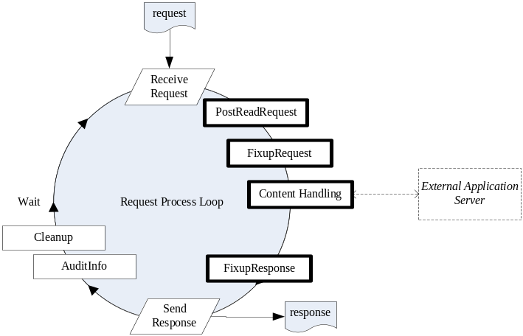
The bolded procedures are where a StreamSmith module, plugin, can hook and customize

Stream Item State Diagram

Each item within the playlist will follow the below state changes:

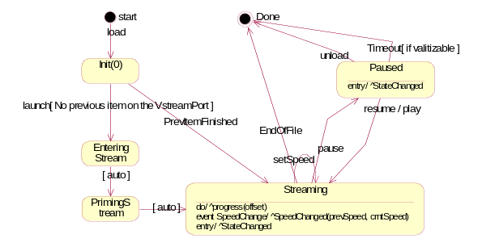

Dynamic Server-side Playlist

In addition to the above state diagram on each individual item, the playlist can be divided into the following stages based on the current streaming position:
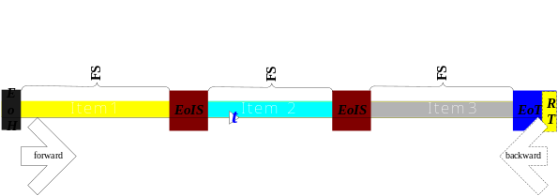
- FreeStreaming (FS) – the range between two protection edges within a streamable item. Speed-changes to any other speeds will be applicable in this stage, and any stages can seek into this stage.
- EdgeOfHeader (EoH) – the protection edge at the beginning of the leading item in a list. In this stage, change to another backward speed is forbidden.
- EdgeOfItemSwitch (EoIS) – the protection edge consist of the last 10 seconds of a previous item and the first 10 seconds of the successor item. Once the streaming enters this stage, the next item in the same direction will be pre-loaded and all speed changes will be denied
- EdgeOfTail (EoT) – the protection edge at the end of last item of the list. It is configurable and should be longer than RealtimeTail. Once the streaming enters this stage, the streaming will be forced to be normal speed. Speed changes to any forward direction will be denied.
- RealtimeTail (RT) – this is a native Vstream feature, it overlaps partial EoT at the end. Any forward speed will be adjusted to normal when the streaming reaches this.

The following is the state summary of the above playlist stages:

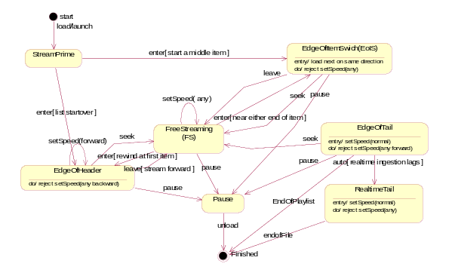

Software and Hardware Requirements

MediaCluster Node | Version
Operating System | Windows 2003
Vstream Kit | Version 5.3.11, 5.4
OpenSSL | Version 0.9.8a

